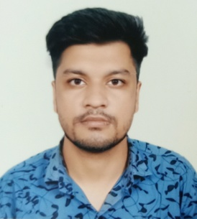
SUMIT DIGARSE
ADDRESS : B-6, rajved colony, E-Mail:digarse98@gmail.com
Near sai steel,
kolar road, Mobile: 9522544993
Bhopal.462042

OBJECTIVE

I am looking for an organization in which I am able to utilize by all skills and ability. I wish have to job which could make the best possible use of my potential to the maximum willing to work as a key player in creative environment.

ACADEMIC PROFILE

- Bachelor in Computer Science Engineering in 2020 from Radharaman Engineering College, Bhopal (RGPV Bhopal University) with Degree 66.20%
- Passed Higher Secondary in 2016 from Rose Mary Hr. Sec. School ,Bhopal with 42.8%
- Passed High School in 2014 from Green Valley School , Bhopal with 57%

TRAINING

- 15 days Vocational Training on "Digital Ion " Bhopal,(M.P.)
- Study about Python.

ACADEMIC PROJECT

MAJOR PROJECT: Bikers Hub Communicative service.

COMPUTER SKILLS

- General: Basics of Computer Hardware & Software
- Good in using Microsoft Office( ms-word, ms-excel, ms-powerpoint)
- Basic knowledge of C, C++, Python and Data Structure.
- Knowledge of Internet.

STRENGTH

My Personal Strength is Patience ,Positive Thinking ,Time Management ,Social intelligence and Confidence.

HOBBIES

Internet surfing, listening music, playing cricket and travelling.

PERSONAL INFORMATION

Name : Sumit Digarse
Father’s Name : Mr. Diwakar Digarse
Date Of Birth : 21 May 1998
Nationality : Indian
Languages Known : English & Hindi
Marital Status : Unmarried

DECLARATION

I here by declare that the information furnished above is true to the best of my knowledge and belief.I Should be held responsible for any fake details and thus be credited to any action against me.
Rest assured, if given a chance will render exemplary service .

Place: Bhopal
Date: SUMIT DIGARSE

