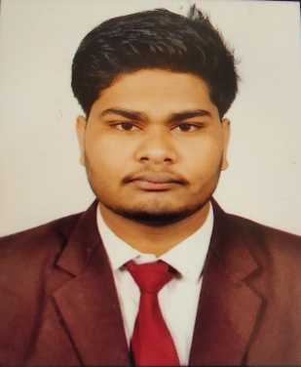

MAYANK SAVITA
B. Tech: - Computer Science and Engineering
 mayanksavita111@gmail.com
 7223018774
 www.linkedin.com/in/mayank-savita04
 Shujalpur (M.P)


Career Objective
To work in a reputed company that will utilize my knowledge and skills and helps me to achieve my goal. It will provide me an opportunity to develop new skills and strengthen my knowledge
Key Expertise

- JAVA | - C++
- Data Structure | - HTML
- Database Management System | - CSS
- Flutter


Education

S no. | Class / Degree | School / College | Board / University | Percentage/ CGPA | Year
1. | B.Tech | Technocrats Institute of Technology | Rajiv Gandhi Proudyogiki | 7.74 | 2017 -2021
2. | Higher Secondary | Govt Sharda Boys Higher Secondary School Shujalpur | Madhya Pradesh Board of Secondary Education | 77.8 | 2017
3. | Higher Secondary | Govt Sharda Boys Higher Secondary School Shujalpur | Madhya Pradesh Board of Secondary Education | 77.1 | 2015

Pro
jects

- Title: - Food Planet App
Technology Used: - Java, MYSQL, Oracle 10g.
Description: - To design a desktop application for a restaurant to handle its activity.


Training / Workshops

1) Android App Development (What After College)
Institute Name: Maulana Azad National Institute of Technology, Bhopal
2) Short Term Training: - Machine Learning with Python
Institute Name: Technocrats Institute of Technology,
Under TEQIP-13 by Rajiv Gandhi Prodyogiki Vishwavidyalaya, Bhopal


Certification

- Oracle Certified Associate, Java SE 8 Programmer (Certificate no 272822455OCAJSE8)
Credential URL: - https://www.youracclaim.com/badges/08061ebd-cf63-4710-bd2b-5725a897f767/linked_in_profile
- Java from Solo Learn (Certificate no #10686511783)
Credential URL: - https://www.sololearn.com/Certificate/1068-6511783/pdf/
- HTML Fundamentals course from Solo Learn (Certificate no #10146511783)
Credential URL: - https://www.sololearn.com/Certificate/1014-6511783/pdf/
- CSS Tutorial course from University of Michigan in Coursera (Certificate no coursera.org/verify/D2KG6YD88WUF)
Credential URL: - https://coursera.org/share/580091895988b8e05f42bf8bb728c60d
- PHP Tutorial course from Solo Learn (Certificate no #10596511783)

Credential URL: - https://www.sololearn.com/Certificate/1059-6511783/pdf/
Personal Information

Father’s Name: - Mr. Dinesh Savita
Date of Birth: - 4 March 2000
Nationality: - Indian
Language: - English, Hindi
Address: - House no. 558, Krishna Nagar Colony, Shujalpur Mandi, Distt. Shajapur (Madhya Pradesh) Pin code: -465333
Hacker Rank id: - https://www.hackerrank.com/mayanksavita111
Hacker Earth id: - https://www.hackerearth.com/@mayanksavita111



Hobbies
    - Mobile Photography |     - Listening to Music
- Traveling | - Outdoor Games
Skills
- Leadership
- Time Management
- Workaholic
- Quick Learner
- Flexible

Extra-Curricular Activities
- Campus Administer Techfest of RGPV, Bhopal.
- Volunteer for short-term training which is held in the Technocrats Institute of Technology.
- Participate in College activities such as Gaming, Sports.
- Volunteer for Navjeevan NGO, Shujalpur in School Days.
- Volunteer for ABVP competition which was held in my city Shujalpur



