Resume
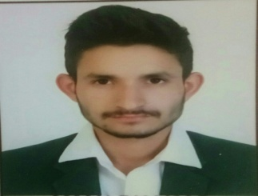
Candidate Name : Aman Dhakad
Mobile No. : 9009363884
Email ID : amandhakad10@gmail.com

CAREER OBJECTIVE
To pursue and obtain a challenging technical position with an organization that provides me an opportunity to grow and to contribute to overall success of the organization.
ACADEMICS
Qualification | Institution | University/ Board | Marks Obtain | Year of Passing
Bachelor of Technology  (Computer Science & Engineering) | LNCT Group of Colleges, Bhopal | R. G. P. V., Bhopal | 7.8 CGPA  (up to 6th sem.) | 2021
Higher Secondary (XII) | Talent Innovative H. S. School, Ashta (M.P.) | M. P. Board, Bhopal | 87.4 % | 2016
High School(X) | Talent Innovative H.S. School, Ashta (M.P.) | M. P. Board, Bhopal | 80.8 % | 2014

INTERNSHIPS & PROJECTS
- E – FARMING(Web Application)
Frontend: HTML, CSS, JAVASCRIPT.
Backend : Java
Database : Oracle

- Mediclinic(Desktop Application)
Frontend: GUI Component
Backend : Java
Database : Oracle
TECHNICAL SKILLS
- Known Programming Languages : C, JavaSE, C++.
- Subject of interests : DBMS, OOPS, SQL.
ACHIEVEMENTS
- Java training through project based learning app by Wipro
- Java Certification through NPTEL.
- C Certification through NPTEL.
- C++ From SCA Bhopal.
PERSONAL DETAILS
- Date of Birth : 03-Feb-1999
- Father’s Name : Dinesh Dhakad
- Mother’s Name : Pavitra Bai
- Current Address : ward no.6, Village Kumdawda, District Sehore, Pin 466125(MP).
- Permanent Address : ward no.6, Village Kumdawda, District Sehore, Pin 466125(MP).
- Hobbies : Playing Cricket,Watching Movies.
- Nationality : Indian
- Languages Known : Hindi, English
- Any kind of disability : No
- Willingness to Relocate : Yes
DECLARATION
I hereby declare that all the above-mentioned information is true and correct to the best of my knowledge.
Place : Sehore (M.P.) Signature/E-signature : 

